The Greenhouse Effect & Greenhouse Gases

The Greenhouse Effect
How does the greenhouse effect work? As is the case with anything involving Earth's atmosphere, the full story is complicated. However, the basic idea is fairly straightforward. Let's take a look at two descriptions of the greenhouse effect; the first is simpler than the second. You can decide which is most suitable for your students.

A Simple Explanation of the Greenhouse Effect
Visible light from the Sun arrives at the top of Earth's atmosphere. As the light enters the atmosphere, some of it is scattered by air molecules or reflected from white clouds back into space. Since air is mostly transparent to visible light, much of the light that isn't reflected back into space goes through the atmosphere to Earth's surface. Some of the light that makes it to the surface is also reflected back into space (especially if the surface is bright, as is the case when snow or ice covers the ground). However, since the average albedo of Earth's surface is around 15%, most of the light that makes it to the surfaces is absorbed, warming our planet. Overall, slightly less than half of the the sunlight at the top of our atmosphere is absorbed by Earth's surface.
These two simple cartoons show the multiple paths sunlight takes as it enters Earth's atmosphere (left) and the basic mechanism of the greenhouse effect (right). The portion of incoming sunlight that is absorbed by Earth is re-emitted as infrared radiation. Some IR energy escapes directly to space, but most is absorbed by greenhouse gases in the atmosphere. This warms Earth's atmosphere; our atmosphere would be roughly 30° C (54° F) colder if it contained no greenhouse gases!
Credit: The COMET Program
Any object warmer than absolute zero gives off electromagnetic radiation. Hot objects give off high energy, short wavelength photons; cooler objects emit lower energy, longer wavelength photons. Earth's surface, heated by the incoming sunlight, emits relatively long-wavelength infrared photons. These IR photons move upward from the surface through the atmosphere. Here's where the greenhouse effect comes in! The atmosphere, which is mostly transparent in visible light wavelengths, is definitely not transparent at IR wavelengths. A small amount of the upward flowing IR shoots directly out into space, but the majority of it is absorbed by the atmosphere. This influx of IR energy heats the atmosphere, which in turn re-radiates IR photons. Some go up, while others go down. Eventually the IR photons escape into space, but some make several round trips between the ground and the atmosphere before they depart. Along the way, a lot of energy is transferred to the ground and the atmosphere. That energy becomes heat which warms Earth's surface and its atmosphere.
In the context of the greenhouse effect, you will sometimes see the outgoing IR radiation referred to as "longwave" radiation. In part, this terminology refers to the fact that infrared radiation has a longer wavelength than visible light. However, it additionally carries the nuance that the atmosphere is more opaque to IR waves towards the long wavelength portion of the IR spectrum, and more transparent to IR waves towards the shorter wavelength (closer to visible light wavelengths) end of the IR spectrum. This image may help you visualize this concept.
Although there is lots of troubling news these days associated with the greenhouse effect and global warming, the basic greenhouse effect is actually quite a good thing for life on Earth. Earth's average surface temperature is around 15° C (59° F). Without the greenhouse effect, it would be about 30° C (54° F) colder than that! The greenhouse effect is what keeps our entire planet from freezing over!

A Explanation of the Greenhouse Effect in Terms of Earth's Energy Budget
If you are satisfied with the basic explanation of the greenhouse effect presented above, feel free to skim or even skip over this section. We now present a somewhat more complex explanation of the greenhouse effect that relies on the physics of energy budgets and equilibrium. We'll reference the diagram of Earth's energy budget (below) in this discussion.
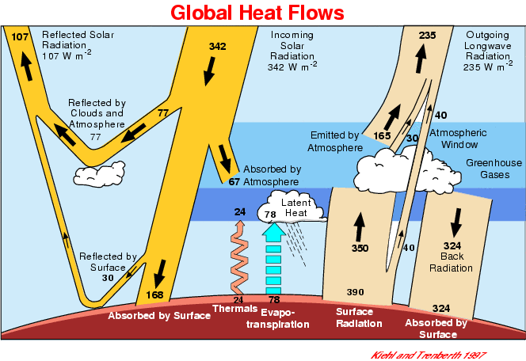
Earth's energy budget diagram. Incoming sunlight is on the left; outgoing infrared or "longwave" radiation is on the right.
Credits: From Kiehl, J. T. and Trenberth, K. E. (1997). "Earth's Annual Global Mean Energy Budget". Bulletin of the American Meteorological Association 78: 197-208.
Let's start by thinking of Earth as a "black box" in terms of its overall energy budget. To be in equilibrium, the influx of energy into the Earth system must equal the outflow; otherwise Earth would be warming up or cooling down. Of course, Earth currently is warming up; but it is very nearly in equilibrium, so we can ignore the very slow warming that is currently underway for the sake of this discussion.
As shown in the diagram, on average (over the entire planet on both the day and night side) the top of Earth's atmosphere receives 342 watts of energy, in the form of sunlight, per square meter. Note that 107 W/m² of this energy is reflected or scattered back into space by clouds, the atmosphere, and high-albedo features on Earth's surface. So, only 235 W/m² (342 - 107) of energy actually make it into the "black box"; it is this amount that must be radiated outward to achieve equilibrium. Note also that 67 W/m² of the incoming energy is absorbed by the atmosphere, and another 168 W/m² is absorbed by Earth's surface. When energy is absorbed, it raises the temperature of the substances that absorb it (the atmosphere and surface of our planet, in this case); this causes those substances to radiate away that heat in the form of IR radiation.
Now let's look at the outgoing IR radiation. Note that 390 W/m² of IR energy starts upward from the surface. But wait! We only had 168 W/m² coming in! Where did all of that extra energy come from? This is where the atmospheric nearly-complete opacity to IR comes into play. Whenever any IR radiation starts upward, nearly 90% of it is trapped by greenhouse gases in the atmosphere before it can escape the "black box" and return to space. So the atmosphere is warmed by the 67 W/m² of incoming sunlight plus most of the IR trying to escape from the surface to space. All of this generates IR radiation emissions from the atmosphere. Some of this IR from the atmosphere does escape to space (the 165 W/m² arrow flowing upward from the atmosphere plus the 30 W/m² flowing upward from clouds). Most, however heads back down towards the surface. That's what the 324 W/m² of "back radiation" is all about. This downward flow is what really pumps up the surface temperature to the point that it can radiate 390 W/m² of energy upward. The greenhouse gases act as a blanket covering Earth's surface; a lot of energy flows back and forth between the insulating blanket and the "body" of the planet beneath; but relatively little escapes from this efficient insulating cover.

Greenhouse Gases
Although Earth's atmosphere is 90% opaque to long wave IR radiation, the vast majority of the atmosphere is not composed of gases that cause the greenhouse effect. Molecular nitrogen (N₂) and oxygen (O₂) make up roughly 98% of our atmosphere, and neither is a greenhouse gas. So, although the greenhouse effect is very powerful, a very small fraction of Earth's atmospheric gases generate the effect.
What are the main greenhouse gases? Because of all the press coverage it has received in recent years, you may think that carbon dioxide (CO₂) is "the big one". Though CO₂'s role is important, water vapor is actually the dominant greenhouse gas in Earth's atmosphere. Water vapor generates more greenhouse effect on our planet than does any other single gas. Water, in gaseous form (as water vapor) and in liquid form (as tiny droplets in clouds), generates somewhere between 66% and 85% of the greenhouse effect. We'll get back to the issue of the large range that "66% to 85%" represents in a minute; it turns out that separating the impact of individual greenhouse gases is not a simple matter.
After water vapor, what are the most important greenhouse gases? In rough order of importance and size of effect, the major ones are carbon dioxide (CO₂), methane (CH₄) and ozone (O₃). There are a number of other gases that contribute to the greenhouse effect to a lesser extent; we'll mention these here in passing for reference, but not consider them further henceforth. These "lesser greenhouse gases" include nitrous oxide (N₂O), sulfur hexafluoride (SF₆), hydrofluorocarbons (HFCs), perfluorocarbons (PFCs) and chlorofluorocarbons (CFCs).
Representations of two important greenhouse gas molecules: carbon dioxide (CO₂) and methane (CH₄).
Credit: Original artwork by Windows to the Universe Staff (Randy Russell).
How do greenhouse gases (GHGs) "work"? These molecules are capable of absorbing passing infrared photons; the energy of the photon is converted into an excited vibrational state of the GHG molecule. Recall that just as visible light has a range of wavelengths with different energies (that we see as colors!), so too the infrared spectrum spans a range of wavelengths with different energies. The various types of GHGs absorb different wavelength IR photons. In fact, the molecules often have more than one vibrational mode that allows them to absorb IR photons of more than one wavelength. This complicates matters when it comes to determining how much of the greenhouse effect each gas produces.
Here's an example. Water vapor absorbs IR photons with wavelengths of 790 nanometers, 940 nm, and 1,375 NM (and at several other wavelengths, too!). Carbon dioxide also absorbs IR photons with wavelengths around 1,375 NM (as well as at several other wavelengths). So it is difficult to say how much of the 1,375 NM IR radiation is absorbed by water vapor and how much is absorbed by CO₂. This brings us back to the "66% to 85%" range of greenhouse effect that is caused by water.
Atmospheric scientists cannot definitively say, based on direct experiments, exactly how much greenhouse effect is caused by each GHG. They cannot simply remove one gas and see how the absorption of IR photons changes. Instead, they must use models of the atmosphere to predict the likely changes. So, they run their models with one GHG removed; say, for instance, water vapor. They might find that this results in a 36% reduction in the greenhouse effect. Note, however, that the absorption of 1,375 NM IR photons by CO₂ would increase in this scenario; the CO₂ need no longer "compete" for these photons with the water vapor. In essence, the 36% reduction in greenhouse effect computed by this method is a minimum; the impact on the total greenhouse effect from water vapor is actually larger. The end result is that there are rather larger ranges of values associated with the possible contributions of the various GHGs to the total greenhouse effect.
So, given all this, what are those ranges? The table below summarizes the contributions of each of the major GHGs to the overall greenhouse effect. Note that, due to the aforementioned complications, the percentages don't add up nicely to 100%.
Major Greenhouse Gas | % of Greenhouse Effect
Water vapor | 36% to 66%
Water vapor & Cloud droplets | 66% to 85%
Carbon dioxide | 9% to 26%
Methane | 4% to 9%
Ozone | 3% to 7%

How do greenhouse gases "work"?
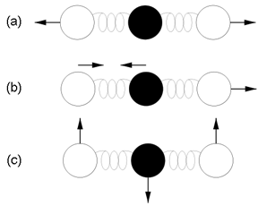
Vibration modes of carbon dioxide. Mode (a) is symmetric and results in no net displacement of the molecule's "center of charge", and is therefore not associated with the absorption of IR radiation. Modes (b) and (c) do displace the "center of charge", creating a "dipole moment", and therefore are modes that result from EM radiation absorption, and are thus responsible for making CO₂ a greenhouse gas.
Credit: Martin C. Doege
If you are up on your chemistry, you may have noticed that all of the greenhouse gas molecules have three or more atoms. Molecular nitrogen (N₂) and molecular oxygen (O₂), the two most abundant gases in our atmosphere, each have only two atoms per molecule, and are not greenhouse gases. This is not a coincidence. As was mentioned earlier, GHG molecules are capable of absorbing passing infrared photons; the energy of the photon is converted into an excited vibrational state of the GHG molecule. So why don't nitrogen and oxygen molecules absorb infrared photons?
Photons, including infrared photons, are of course a form of electromagnetic radiation. As such, they can also be understood as disturbances, or waves, of electromagnetic energy. Atoms, and the molecules they combine to form, have electrically charged particles (electrons and protons) in them. The gas molecules we are currently considering, nitrogen and oxygen and the various GHGs, have no net charge; they have equal numbers of electrons and protons. However, molecules that are on average neutral (in terms of their electrical charge) can still have localized charges, either some of the time (when they are vibrating) or all of the time. For example, surface tension in water is caused by the tendency of water molecules to stick together because the electrons that the oxygen and hydrogen atoms share are not shared equally. The shared electrons spend more time closer to the oxygen atom's nucleus, which has more protons and thus pulls on the electrons more strongly. The portion of each water molecule that is near the oxygen atom has a negative charge (excess electrons), while the areas around the two hydrogen atoms have positive charges (fewer electrons to offset the protons). Water molecules have localized areas of positive and negative charges, so individual water molecules tend to "stick" to one another (the positive hydrogen segments being attracted to the negative oxygen portion).
Molecules are not, however, rigid ball and stick figures as our chemistry class models may lead us to believe. Molecules are in motion; continuously bouncing around and jiggling and vibrating. Consider first a diatomic nitrogen (N₂) or oxygen (O₂) molecule. A pair of balls attached by a spring is a good model of such a molecule. Pull the balls apart and release them; they alternately move closer together and further apart. This vibrational mode is extremely symmetric, however; the center of mass of the system always remains at the point midway between the two balls/atoms. Electromagnetic "disturbances" (waves) do not tend to interact with, or transfer energy to, such diatomic molecules (such as N₂ or O₂).
Molecules with three or more atoms, however, are a different story. The figure (above, right) shows three different vibrational modes of a carbon dioxide (CO₂) molecule. The first mode, (a), is symmetric; it is comparable to the vibrational mode of diatomic molecules. The center of mass, and of charge, of the system is not displaced during vibration. However, such is not the case for the other two modes, (b) and (c). In the latter two cases, the "center of charge" moves as the molecule vibrates, creating a "dipole moment". As explained for the the case of water above, electrons are not shared equally between the atoms in the CO₂ molecule, so the molecule is not electrically neutral in all places. As the molecule oscillates, the center of charge moves; from side to side in case (b), and up and down in case (c). A passing electromagnetic "disturbance" (wave, or IR photon) can "excite" such a molecule, causing it to vibrate and transferring energy from the photon to the molecule. This is the mechanism by which greenhouse gases absorb energy from infrared photons.

Greenhouse Gases in Earth's Atmosphere
Earth's atmosphere is dynamic; GHGs constantly flow into and out of the atmosphere. Where do they come from? Where do they go? How much of each major type of GHG is currently in our atmosphere? How has that changed over time? Let's take a look at the answers to each of these questions.
Water vapor is the most important GHG. Along with small water droplets in clouds, it produces somewhere between 66% and 85% of the greenhouse effect. The water (or hydrologic) cycle describes the movements of water through the Earth system. About 90% of the water in the atmosphere gets there as a result of evaporation; most of the remaining 10% comes from evapotranspiration. Roughly 95% of evaporation comes from the world's oceans. Water vapor in the atmosphere condenses to form the tiny droplets in clouds or freezes to form ice crystals; precipitation in the form of rain, snow, sleet, hail, and so on removes the water from the atmosphere. The average "residence time" for a water molecule in the atmosphere is a surprisingly brief nine days. We'll examine the role of the water cycle in climate further in the readings about "Global Warming, Clouds, and Albedo" and "Aerosols, Cloud Nucleation and Global Dimming", as well as in the second week of the course which covers the hydrosphere.
Carbon dioxide is the second most important GHG, producing some 9% to 26% of the greenhouse effect. The carbon cycle describes the ways in which carbon moves through the Earth system; carbon dioxide in the atmosphere is just one of many aspects of the carbon cycle. Carbon dioxide concentration in the atmosphere is quite low; slightly less than 0.04%. It is usually described in terms of parts per million by volume (ppmv); the current value is around 383 ppmv. Natural sources of CO₂ include volcanic outgassing, combustion of organic matter, respiration of living aerobic organisms, and fermentation by microbes. About three-fourths of anthropogenic CO₂ emissions result from burning fossil fuels for heating, power generation, and transportation. Most of the rest of human CO₂ emissions are a result of land use changes, especially deforestation. Processes that remove carbon dioxide from the air are called "carbon sinks". Trees and other plants absorb CO₂ during photosynthesis; the carbon is converted into plant materials and into soil as the plants die and decay or shed leaves. Oceans absorb large amounts of CO₂, either directly through chemical processes that dissolve carbon dioxide into seawater, or indirectly via living organisms that take up the gas and transport it from the ocean surface to greater depths.
The last major greenhouse gas we'll consider here is methane. Methane exists in even smaller quantities in our atmosphere than does carbon dioxide; its abundance is usually expressed in terms of parts per billion by volume (ppbv). Currently, methane concentration is around 1,775 ppbv. Natural sources of methane in Earth's atmosphere include the decay of organic materials in wetlands, termites, emissions from the oceans, and the melting of methane hydrates (ices made of methane found in the ocean floor). Recent studies have tentatively identified living plants, including forests, as a possible major source of methane emissions; but further studies are needed before this finding can be confirmed. Major anthropogenic sources of methane in the atmosphere include energy production, emissions from livestock including cattle, landfills, biomass burning, and waste treatment. Removal of methane from the air is primarily a result of chemical reactions in which the gas combines with the hydroxyl radical (OH⁻), which forms when cosmic rays or other energy sources split apart water molecules. Uptake by soil microorganisms and other chemical reactions in the stratosphere also remove small amounts of methane. The average lifetime of methane in the atmosphere is 12 years.

Changes in Amounts of Greenhouse Gases in the Atmosphere in Recent Times
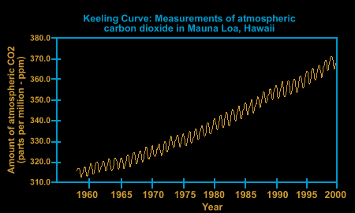
The Keeling Curve shows data from direct measurements of atmospheric CO₂ concentration from 1958 onward.
Credit: Original artwork by Windows to the Universe staff based on data from NOAA and UCSD.
Because there are natural sources of (and sinks for) the various GHGs, the concentrations of these gases have fluctuated all throughout Earth's history. However, human activities, especially ones associated with the industrial revolution, have increased anthropogenic emissions of several important GHGs dramatically since the mid 1800s. Various human activities have altered the natural mix of a broad range of gases that play a role in determining climate. Our focus here, however, will be on alterations in carbon dioxide and methane levels since pre-industrial times.
Direct measurements of atmospheric CO₂ concentration have been recorded since 1958. In that time, the concentration has risen from 315 ppmv to 380 ppmv (in 2006). The graph at right, known as the Keeling Curve, shows CO₂ concentration data from 1958 through 2000. The Keeling Curve draws its name from Charles David Keeling of the Scripps Institution of Oceanography, who was the first person to make frequent regular measurements of CO₂ concentration. The regular annual wiggles in the graph reflect seasonal changes; as plants in the Northern Hemisphere, which has far more land area, begin to grow each spring, they remove some CO₂ from the air via photosynthesis, causing the graph to dip slightly. The opposite effect appears during each Northern Hemisphere autumn.
To examine times before systematic direct measurements began in 1958, scientists rely on data from bubbles trapped in polar ice cores. Though not quite as precise as direct atmospheric sampling, these data correlate well with direct measurements during the periods when the two data sets overlap, providing us with confidence that the ice core records are indeed accurate. The oldest ice core records now extend back roughly a million years. For the past several thousand years, up until the last couple of centuries, average CO₂ concentration hovered in the 250 to 280 ppmv range. Ice core data indicates that CO₂ concentration hadn't previously risen above 300 ppmv in at least the past 300,000 years. Less direct geologic records appear to indicate that the last time CO₂ concentration was as high as it is today was about 20 million years ago. The graph below, which includes both direct measurements and ice core data, shows that carbon dioxide levels have been steadily rising since at least about 1850; and have risen sharply since around 1950. This rise corresponds to a period of dramatically increased CO₂ emissions from the burning of fossil fuels that have been used to power humanity's industrial revolution. Atmospheric CO₂ concentration has risen at least 35% above pre-industrial levels (from 280 to 380 ppmv).
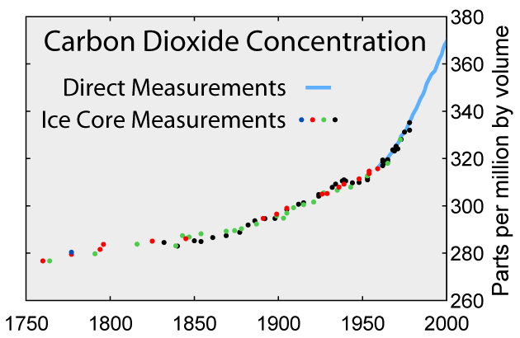
This graph shows global average atmospheric concentrations of carbon dioxide over a 250 year period from 1750 to 2000. The light blue line indicates actual direct atmospheric measurements. The colored dots indicate data gathered from ice cores; each color represents a different ice core sampling site.
Credit: Robert A. Rohde and the Global Warming Art project.
Direct measurements of methane concentration began later than the corresponding carbon dioxide measurements. However, ice cores also provide scientists with methane concentration data extending back many thousands of years. Pre-industrial levels of methane were around 700 ppbv in 1750. By 1998, methane concentration had risen to 1,745 ppbv; a whopping 149% increase over pre-industrial levels! Unlike CO₂ concentration, which is increasing rapidly even now, methane levels have, at least temporarily, plateaued in recent years (as shown in the graph below). Some scientists hypothesize that severe droughts in certain regions have reduced methane emissions from wetlands in the last few years, though this claim is far from proven.
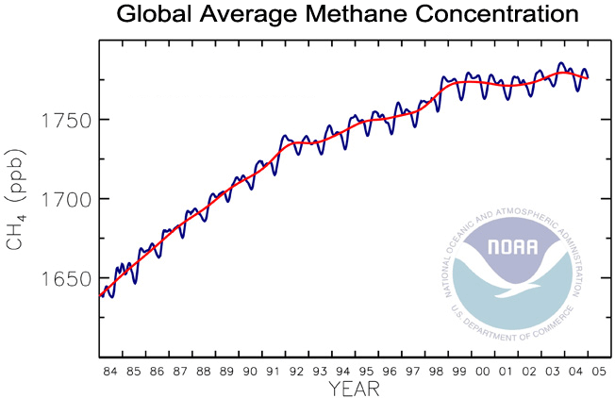
This graph shows the global average methane concentration in Earth's atmosphere from 1984 through 2004. The blue line indicates actual values; the red line shows the longer-term trend. Units are parts per billion (ppb) by volume.
Credit: Image courtesy NOAA.

Radiative Forcing & Global Warming Potential (GWP)
Finally, we'll look at two last concepts that help explain the overall impacts of increases in GHGs. The first is the expression of the radiative forcing associated with the increase of a particular GHG. The second is the concept of Global Warming Potential (GWP). Once again, most of our focus will be on carbon dioxide and methane.
Greenhouse Gas | Radiative Forcing
Carbon dioxide | 1.532 W/m²
Methane | 0.48 W/m²
CFC-12 | 0.17 W/m²
Nitrous oxide | 0.15 W/m²
Glance back at Kiehl and Trenberth's energy budget diagram that was introduced early in this reading. Recall how the energy associated with various emitters and absorbers of light and infrared radiation was expressed in terms of watts per square meter (W/m²). Climate scientists use these same units to express the net change to Earth's energy balance caused by increased levels of greenhouse gases. In effect, they are stating that an increase in a given greenhouse gas causes a net change in the downward flowing energy minus the upward flowing energy. This radiative forcing value is expressed in terms of W/m². It depends on two factors; the "potency" or "greenhouse strength" of a given GHG, and the amount of increase in that gas in the atmosphere. Methane is a much more "potent" GHG ("pound for pound") than is carbon dioxide, but the increase in the quantity of carbon dioxide (not the percentage increase!) has been much greater (remember, parts per million for CO₂ versus parts per billion for methane). As shown in the table (right), the radiative forcing generated by increased levels of carbon dioxide (over pre-industrial values) is about three times as great as the radiative forcing generated by methane. So the net effect on global warming today produced by increased levels of CO₂ is about thrice as great as is the case for methane. Methane, in turn, has about three times as much impact as the next two most "influential" GHGs, chlorofluorocarbon-12 and nitrous oxide. The radiative forcing generated by each of the other minor GHGs is less than 0.1 W/m².
Global Warming Potential (GWP) adds one more factor into the consideration of the relative importance or "effectiveness" of the various GHGs. Some gases linger in the atmosphere far longer than others before natural processes remove them. In the case of a GHG, the Global Warming Potential (GWP) takes into account the fact that a GHG that lingers longer has a greater cumulative contribution to the greenhouse effect over its "lifetime" than does a gas that is quickly removed. Recall that water vapor tends to cycle out of the atmosphere in a matter of days; water vapor, therefore, has a negligibly small GWP. Methane takes, on average, about 12 years to disappear from the atmosphere. Carbon dioxide takes centuries. Some gases take even longer periods of time! GWP is stated in terms of a given time interval, such as "the GWP for a 20 year time horizon" or "the GWP for a 100 year time horizon"; this latter is the most commonly stated time period for GWP. Carbon dioxide is used as the reference gas, and therefore, by definition, has a GWP of precisely 1. A definition of GWP could be stated something like: the total radiative forcing produced by a given amount (such as one kilogram) of a particular GHG over the entire course of a specified time period (most commonly a century) as compared with the same amount of carbon dioxide. Methane, which is "pound-for-pound" a much more "potent" GHG than CO₂ has a GWP of 62 over a 20 year period. Over a 100 year period, the GWP of methane is a much-reduced 23; though methane is more "potent" than carbon dioxide, it is also "shorter-lived", which tends to offset its total contribution to the greenhouse effect. Nitrous oxide, which is both a very "potent" GHG and a long-lived one (atmospheric lifetime of 114 years), has a GWP of 296 on a 100 year scale. Some fluorocarbons have GWP values of more than 1,000 or even more than 10,000; we would have some really big problems if we released large quantities of them into the atmosphere!
Last modified June 1, 2007 by Randy Russell.

