Fossil Fuel pipelines
History of Natural Gas
Naturally occurring natural gas was discovered and identified in America as early as 1626, when French explorers discovered natives igniting gases that were seeping into and around Lake Erie. In 1821, William Hart dug the first successful natural gas well in the U.S. in Fredonia, New York.
In 1836, the City of Philadelphia created the first municipally owned natural gas distribution company. Today, U.S. public gas systems number more than 900.
During most of the 19th century, natural gas was used almost exclusively as a source of light, but in 1885, Robert Bunsen's invention of what is now known as the Bunsen burner opened vast new opportunities to use natural gas. Once effective pipelines began to be built in the 20th century, the use of natural gas expanded to home heating and cooking, appliances such as water heaters and oven ranges, manufacturing and processing plants, and boilers to generate electricity.

Natural Gas Today
Today, natural gas is a vital component of the world's supply of energy. Natural gas currently supplies more than one-half of the energy consumed by residential and commercial customers, and about 41 percent of the energy used by U.S. industry.
Ninety-nine percent of the natural gas used in the United States comes from North America. Currently there is a nationwide two million-mile underground natural gas delivery system.
Liquefied natural gas (LNG) is beginning to play a more prominent role in the overall gas supply picture. Although about one percent of the natural gas consumed in this country is currently imported as LNG, it is estimated that our nation's imports of LNG will grow to approximately 7 or 8% by the end of this decade. This will require more than the four LNG facilities that currently exist.
Natural Gas Regulation
In 1989, the Natural Gas Wellhead Decontrol Act (NGWDA) repealed all
remaining regulated prices on wellhead sales. In the current federal regulatory environment, only interstate pipelines are directly regulated as to the transportation of gas in interstate commerce regarding the rates they charge, the access they offer to their pipeline facilities, and the siting and construction of new pipelines.
Local distribution companies (excluding most municipally owned public gas systems) are regulated by state public service commissions, which oversee their rates and construction issues, and ensure that proper procedures exist for maintaining adequate supply to their customers.

The Proposed Mountain Valley Gas Pipeline
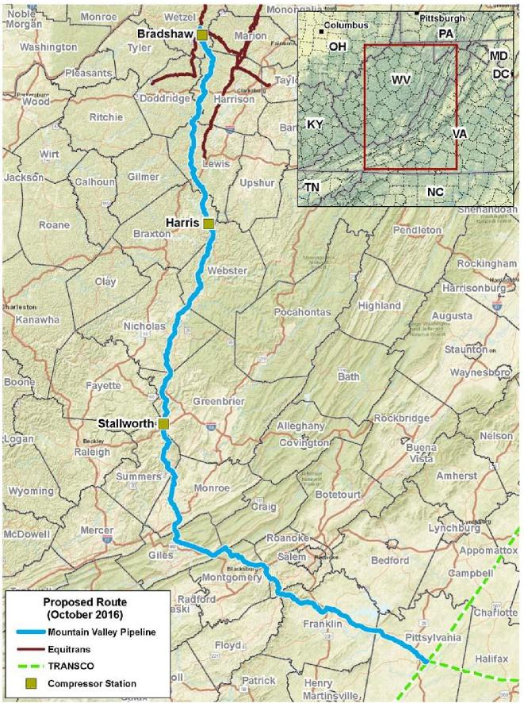
The Mountain Valley Pipeline (MVP) project is a natural gas pipeline system that spans approximately 301 miles from northwestern West Virginia to southern Virginia - and as an interstate pipeline will be regulated by the Federal Energy Regulatory Commission (FERC). With a vast supply of natural gas from Marcellus and Utica shale production, the Mountain Valley Pipeline is expected to provide up to two million dekatherms per day of firm transmission capacity to markets in the Mid- and South Atlantic regions of the United States. The pipeline will be up to 42 inches in diameter and will require approximately 50 feet of permanent easement (with 125 feet of temporary easement during construction). In addition, the project will require three compressor stations.

Potential threats of Mountain Valley Pipeline as stated by an advisory committee: Threats to water and wells
Threats associated with blasting through bedrock to excavate a trench to a depth of about 7 to 10 feet for a 42-inch-diameter natural gas pipeline.
Threats to air quality. Threats to public safety. Threats to property values.
Threats to wildlife and endangered species, and endangered ways of life, such as earning a living from the land.
Use of eminent domain for right-of-ways.
Damage heavy equipment could do during pipeline construction to rural roads and bridges. Threat that once it's abandoned, the steel pipeline will rust and collapse, leaving a landscape etched by scars impacting local residents and the elderly.
Support of the Pipeline
The Roanoke Regional Chamber of Commerce board of directors had voted to endorse the $3.2 billion Mountain Valley Pipeline because of potential economic benefits that could include providing access to natural gas for Franklin County.

Other pipeline projects
Constitution Pipeline
The Constitution Pipeline, planned to stretch 125 feet wide and 124 miles long starting near
Dimock, PA and crossing over 275 streams and waterways, would have required the cutting of as many as 700,000 trees in Pennsylvania and New York, part of a build-out project estimated to cost investors as much as $1 billion. There are concerns about tree-felling in watersheds, but also the impacts the pipeline and its construction would have on the New York's streams and wetlands, and even threats to old growth forests in the eastern U.S. — from the proposed construction.
NED Pipeline
The TGP Northeast Energy Direct pipeline is a 30″ inch high-pressure natural gas transmission line. It would be bringing gas directly from the fracking fields of PA through to the eastern hub in Dracut MA. This proposed path would run through some of the states’ most sensitive eco-systems including conservation lands, wildlife reserves, state parks as well as farmland, towns and even crossing over or under the Connecticut River. The proposed pipeline would cross through multiple private properties as well as conservation lands, including multiple wetlands and at least 5 town drinking water aquifers.
Algonquin Incremental Market Pipeline (AIM)
Spectra Energy is pursuing the ‘Algonquin Incremental Market (AIM) Project’, which would run natural gas from the Appalachian Basin up to New York, Connecticut, Rhode Island and Massachusetts. The source of the natural gas is the Marcellus shale in Pennsylvania. Risks include: • Unacceptably dangerous route and convergence of extreme risks! Proposed high pressure 42” diameter pipeline would cross from Stony Point, Rockland County under the Hudson River into Westchester County, NY, intersect two proposed mega voltage power lines just a few hundred feet from Indian Point nuclear power plant and 40 years of spent nuclear fuel rods.
Sabal Trail pipeline
Sabal Trail project is a $3 billion 515-mile pipeline of interstate natural gas pipeline (86 miles in Alabama, 162 miles in Georgia, 268 miles in Florida). Behind the project are Spectra Energy Corp, NextEra Energy, Inc., and Duke Energy. Sabal Trail's proposed route will go through low-income African-American neighborhoods. The proposed industrial compressor station facility would sit right in the middle of the neighborhood. Sabal Trail.The suit says the project poses a threat to drinking water sources in the region.
Millennium Pipeline
The proposed 442-mile Millennium Pipeline, which would deliver natural gas from Canada to Mount Vernon, New York, snakes through significant portions of the Hudson River Valley and would cut through 2.1 miles of critical fish and wildlife habitat in Haverstraw Bay. The proposed route would take the pipeline through environmentally sensitive and productive Haverstraw Bay, requiring blasting.

U.S. Liquid Pipelines

More than 190,000 miles of liquid petroleum pipelines traverse the United States. They connect producing areas to refineries and chemical plants while delivering the products to American consumers and businesses. They move crude oil from oil fields on land and offshore to refineries where it is turned into fuels and other products, then from the refineries to terminals where fuels are trucked to retail outlets. Pipelines operate 24 hours a day, seven days a week.
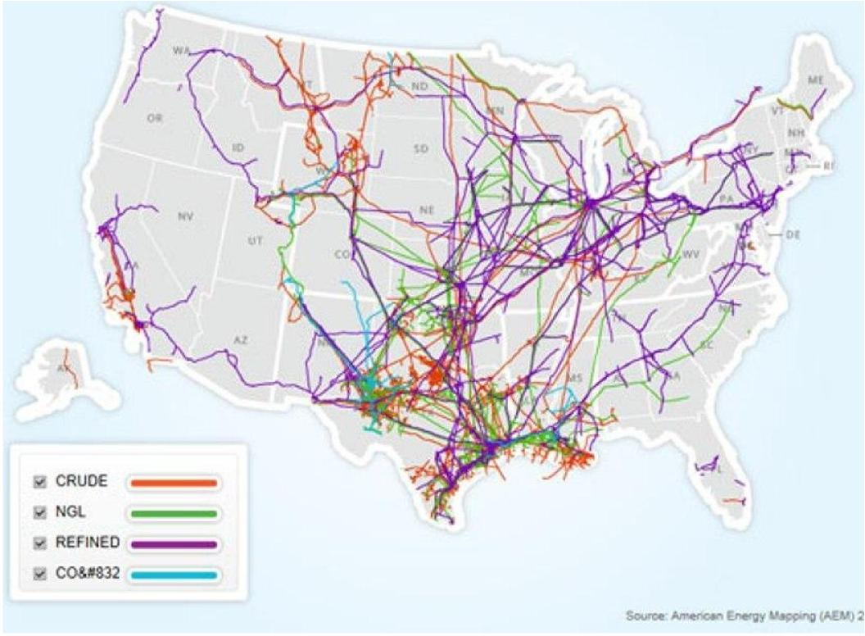

Brief History of Petroleum Production in the U.S.
Petroleum became a major industry following the oil discovery in Pennsylvania in 1859. However, before this, oil-producing wells in the United States were wells that were drilled for salt brine, and produced oil and gas only as accidental byproducts. The principal product of the oil in the 19th century was kerosene, which quickly replaced whale oil for illuminating purposes in the United States.
The first commercial oil well in California was drilled in Humboldt County in 1865. Most California crude oil in the early years was turned into the less lucrative products of fuel oil and asphalt. The discovery of the Long Beach Oil Field in 1921, which proved to be the world's richest in production per-acre of the time, increased the importance of the Los Angeles Basin as a worldwide oil producer, along with the development of the Port of Los Angeles as a means of shipping crude oil overseas. The San Joaquin Basin is the main oil-producing region of California, with huge oil fields producing much of California's onshore oil.
For much of the 19th and 20th centuries, the US was the largest oil producing country in the world. As of October 2015, the US was the world's third-largest producer of crude oil.

Crude Oil Pipelines
The U.S. has the world's largest network of pipelines in the world with more than 207,800 miles of liquids pipelines, over 300,000 miles of gas transmission pipelines, and more than 2.1 million miles of gas distribution pipelines. Liquid petroleum pipelines are usually the only feasible way to transport significant volumes by land over long distances.
Crude oil has been collected by pipelines from inland production areas like Texas, Wyoming, North Dakota, Louisiana, Alaska, and western Canada. Crude also arrives in the U.S. from Mexico, Africa and the Middle East, and South America by marine tankers, often moving for the final leg of that trip from a U.S. port to a refinery by pipeline. For example, crude oil is produced in Alaska, moves south on the 48 inch diameter Trans-Alaska Pipeline System, moves by tank ship to the West Coast and by pipeline to refineries along the west coast of the U.S.
Within the liquid petroleum pipeline network there are crude oil lines, refined product lines, highly volatile liquids (HVL) lines, and carbon dioxide lines (CO2).
Gathering lines are very small pipelines usually from 2 to 8 inches in diameter used in the areas where crude oil is pumped from deep within the earth. The larger cross-country crude oil transmission pipelines or trunk lines bring crude oil from these producing areas to refineries. There are approximately 72,000 miles of crude oil system lines (usually 8 to 24 inches in diameter) in the United States that connect regional markets.
The next group of liquid petroleum pipelines is one that carries refined petroleum products – gasoline, jet fuel, home heating oil and diesel fuel. These refined product pipelines vary in size from relatively small, 8 to 12 inch diameter lines, to much larger ones that go up to 42 inches in diameter. There are approximately 63,000 miles of refined products pipelines nationwide. These pipelines deliver petroleum products to large fuel terminals with storage tanks that are then loaded into tanker trucks. Trucks cover the last few miles to make local deliveries to gas stations and homes. Major industries, airports and electrical power generation plants are supplied directly by pipeline.
Highly volatile liquid (HVL) lines and carbon dioxide (CO2) lines are also a part of the liquid petroleum pipeline network that include ethane, butane and propane. Carbon dioxide pipelines allow carbon dioxide to enhance oil recovery.

Safety of Pipelines
According to the Industry
A barrel of crude oil or petroleum product shipped by pipeline reaches its destination safely more than 99.999% of the time. The number of releases greater than 500 barrels is down 32% since 2011. In addition, most incidents do not impact the public or the environment, with 71% of incidents in 2015 occurring and contained wholly within an operator's facility.
Pipeline operators prepare for the unlikely event of an incident through control room technologies and training to stop the flow of a pipeline quickly upon a release. Operators also develop emergency response plans, deploy resources, and work frequently with local first responders in order to reduce the impacts of any release.

Some of the U.S. Pipeline Oil Leaks 2013-2015
On May 19, a Plains All American Pipeline oil pipeline ruptured near Refugio State Beach spilling out 124,000 gallons of crude oil.
2013
On March 29, an oil spill occurred when ExxonMobil's 20-inch Pegasus crude oil pipeline spilled 300,000 gallons of diluted bitumen near Mayflower, Arkansas, causing crude to flow through yards and gutters, and towards Lake Conway.
On July 26, a leaking BP 20-inch crude oil pipeline in Oklahoma spilled 2100 to 4200 gallons of crude oil into a drainage ditch leading to a water reservoir.
On September 29, a North Dakota farmer discovered a leaking 6-inch 20-year-old Tesoro pipeline under his wheat field. The spill as estimated at 865,000 gallons.
On October 29, a Koch Industries 8-inch pipeline spill about 17,000 gallons of crude oil near Smithville, Texas. The oil polluted a private stock pond.
2014
On October 13, a Sunoco/Mid-Valley crude oil pipeline ruptured, and spilled about 168,000 gallons of crude oil in Caddo Parish, Louisiana. Wildlife was killed.
On December 8, gasoline was discovered leaking from Kinder Morgan Plantation Pipeline in Belton, South Carolina leaked into a nearby creek. The cause was a failure that was part of an earlier repair. 8,000 barrels (42 gallons per barrel) or 300,000 gallons of gasoline leaked.
2015
On January 17, oil from a broken pipeline seeped into the Yellowstone River, and contaminated the water supply 10 miles south of Glendive, Montana. The release was from Bridger Pipeline LLC's 12-inch Poplar line, which can carry 42,000 barrels a day of crude from the Bakken formation and runs from Canada south to Baker, Montana. 30,000 gallons of crude was spilled.
On January 21, a petroleum products pipeline in Honolulu, Hawaii ruptured, due to external corrosion, spilling about 42,000 gallons of petroleum product.

Some of the U.S. Pipeline Oil Leaks 2016
On November 1, at least one person was killed after a Colonial pipeline exploded Monday in Shelby County, Alabama.
On February 24, a 10-inch propane pipeline exploded and burned, near Sulphur, Louisiana. About 208,000 gallons of propane were burned.
On March 11, about 30,000 gallons of gasoline spilled from a leaking plug on a pipeline, at a tank farm in Sioux City, Iowa.
On April 2, the TransCanada Corporation Keystone Pipeline was observed by a local resident to be leaking, near Freeman, South Dakota. The cause was a crack in a girth weld, and amount of tar sands dilbit spill was about 16,800 gallons.
On April 17, a petroleum products pipeline failed in Wabash County, Illinois, resulting in a sheen on the Wabash River. About 48,000 gallons of diesel fuel was spilled.
On April 29, a 30-inch Texas Eastern/Spectra Energy pipeline exploded. Spectra Energy Corp. announced plans to dig up and assess 263 miles of that pipeline, from Pennsylvania to New Jersey. Corrosion had been 4 years before the rupture.
On May 20, a Shell Oil Company pipeline leaked near Tracy, California, spilling about 21,000 gallons of crude oil.
On June 23, a Crimson Pipeline crude oil line leaked in Ventura County, California. 45,000 gallons of crude were spilled.
On September 9, a Colonial Pipeline mainline leak was noticed by workers on another project, in Shelby County, Alabama. 252,000 gallons of gasoline leaked.
On September 10, a Sunoco pipeline ruptured near Sweetwater, Texas. About 33,000 gallons of crude oil were spilled. The pipeline was just over a year old.
On October 21, an 8 inch Sunoco pipeline ruptured in Lycoming County, Pennsylvania, spilling about 55,000 gallons of gasoline into the Susquehanna River.

Oil Train disasters
Jan. 24, 2013 Paynton, Saskatchewan: A CN Rail train collides with a road grader and derails. An estimated 28,000 gallons of crude is spilled from four cars. One death resulted from the collision. Mar. 27, 2013 Parkers Prairie, MN: A mile-long Canadian Pacific train carrying crude oil from Canada derails. An estimated 20,000–30,000 gallons is spilled.
Apr. 3, 2013 White River, Ontario: A Canadian Pacific Rail train derails, spilling an estimated 16,500 gallons of light sweet crude.
May 21, 2013 Jansen, Saskatchewan: A Canadian Pacific Rail mixed freight train derails, spilling an estimated 24,000 gallons of crude.
July 6, 2013 Lac-Mégantic, Quebec: 47 people are killed and nearly entire downtown area destroyed, when a Montreal, Maine and Atlantic Railway train derailed, spilling 1.6 million gallons of crude oil. Nov. 8, 2013 Aliceville, AL: A Genesee & Wyoming train carrying North Dakota crude derails near Aliceville, exploded and burned for more than 18 hours. About 748,800 gallons spilled into surrounding wetlands. After 4 months, oil was oozing into the water.
Dec. 30, 2013 Casselton, ND: A BNSF Railway crude train crashes into another train, leading to the evacuation of 1,400 nearby residents. An estimated 400,000 gallons of crude are spilled.
Jan. 31, 2014 New Augusta, MS: Thirteen cars of a Canadian National Railway train transporting North Alberta crude derails. 90,000 gallons of product were spilled and a dozen nearby homes evacuated. Feb. 3, 2014 Winona, MN: A Canadian Pacific Railway train leaks 12,000 gallons of crude along 68 miles of tracks. The spill is reportedly due to a valve or cap mishap.
April 30, 2014 Lynchburg, VA: A CSX train carrying crude oil derails in Lynchburg, prompting the evacuation of some 300 people. 30,000 gallons are spilled into the nearby James River.
Feb. 16, 2015 Mount Carbon, WV: A CSX Transportation train hauling 107 tank cars of crude oil from North Dakota to Virginia derailed. The spill, fire, and eruptions.
Mar. 5, 2015 Galena, IL : A BNSF train carrying 103 cars filled with Bakken crude oil derails near the Mississippi River, resulting in thick plumes of smoke and fires.
Mar. 7, 2015 Gogama, Ontario: A 94-car CN train carrying Alberta crude to eastern Canada derails. Numerous cars catch fire. Oil spills into the Mattagami River System.
May 6, 2015 Heimdal, ND: A 109-car BNSF train carrying crude oil derails in central North Dakota. Five to ten cars reportedly explode and burst into flames. The nearby town of Heimdal is evacuated. July 17, 2015 Culbertson, MT: A BNSF train carrying 106 cars of crude oil traveling from North Dakota to Anacortes, Washington, derails. An estimated 35,000 gallons of crude spills.
Nov. 8, 2015 Watertown, WI: A 110-car Canadian Pacific train, carrying Bakken crude oil in 109 cars, derails near the downtown area on its way to Pennsylvania. 13 cars jump the tracks, with one car punctured. Hundreds of gallons of crude oil spilled.
June 3, 2016 Mosier, OR: An oil train derails in the Columbia River Gorge. At least eight cars are involved. Flames from the resulting fire could be seen from downtown Mosier. The smoke plume was visible for miles. A nearby school was evacuated.

